Austin Amakye Ansah: 1002033897

Akito Kishi: 1002164565

# Best Price DB Frontend

Stack: API built in Go, Frontend: Preact, fresh, denojs

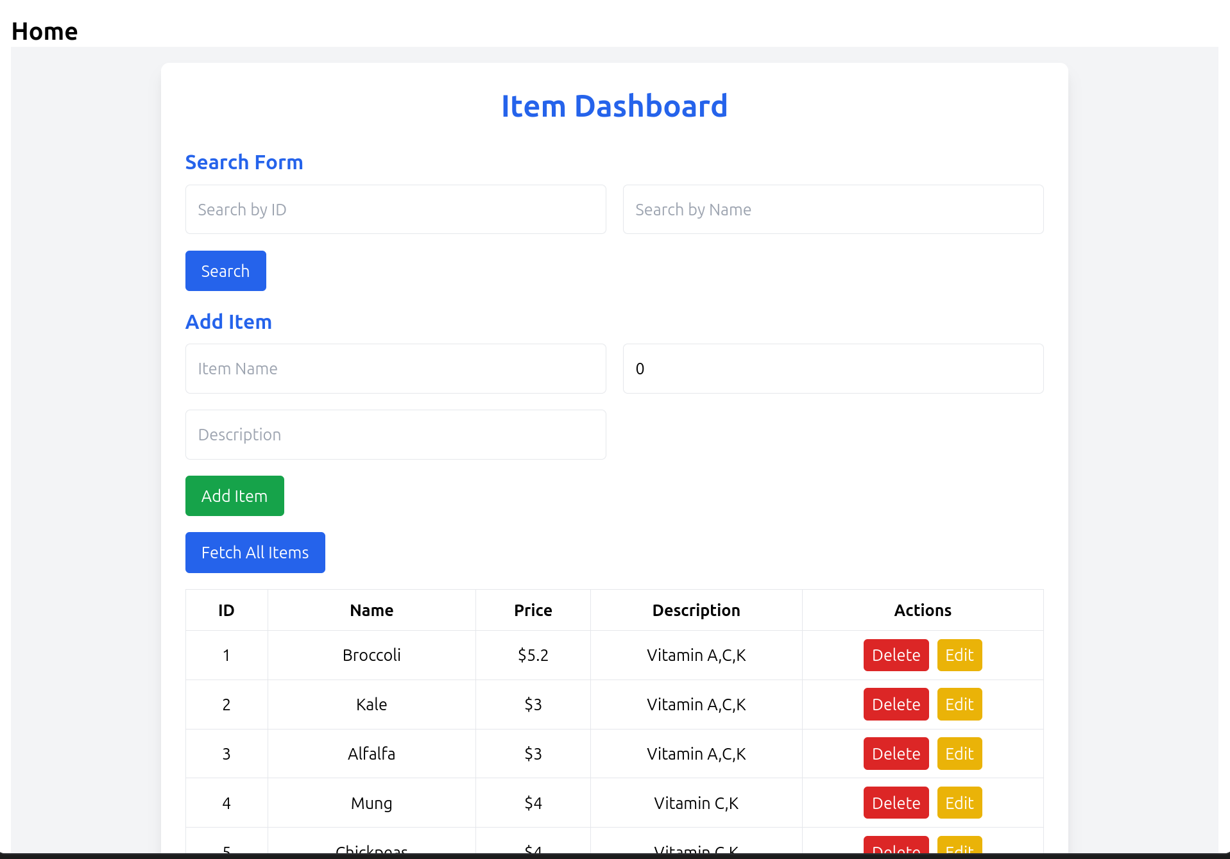

1. Searching by name OR ID

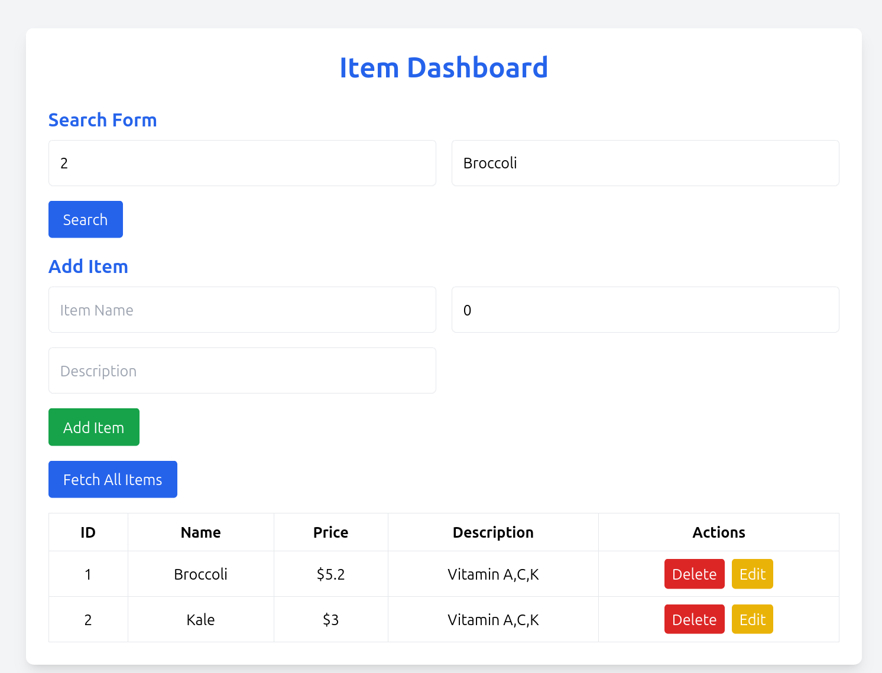

2. Adding Broccoli to DB

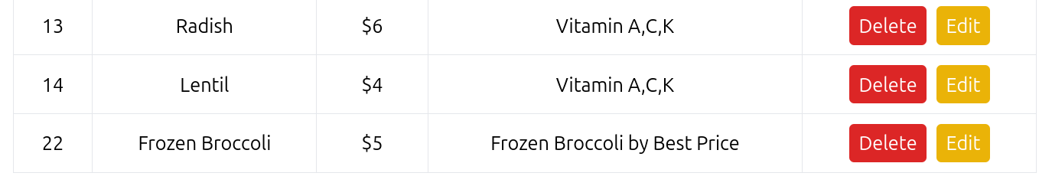

DB ID’s are autoincremented, that’s why there is a 22 here (from previous experimentation)

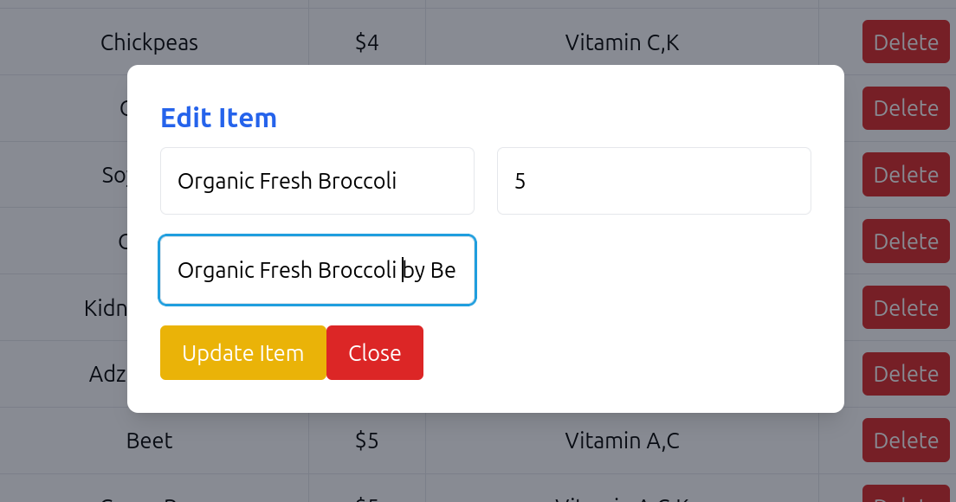

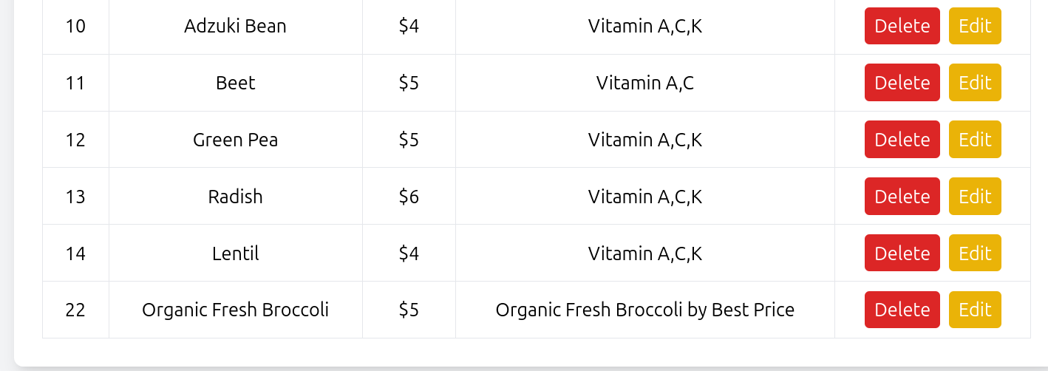

After deletion

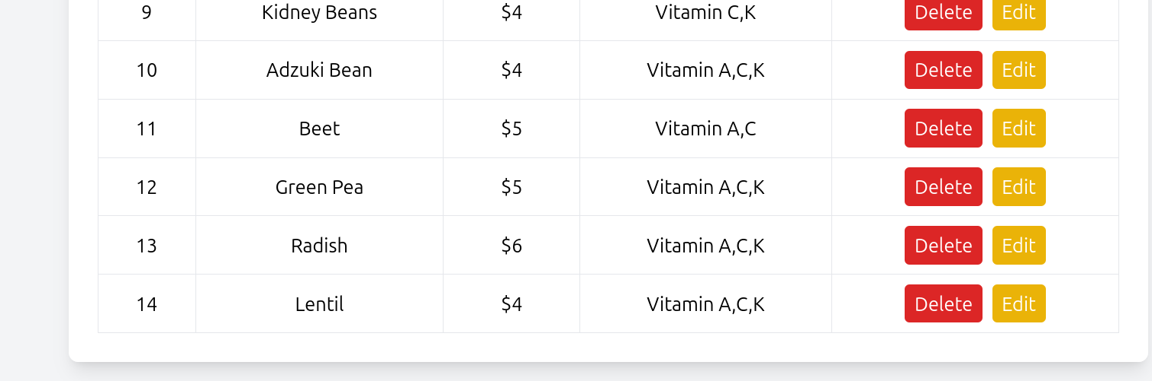

VIEWS

CREATE VIEW VendorContractView AS

SELECT V.vId as VendorId, V.Vname as VendorName, count(C.ctId) as ContractCount, ROUND(avg(VI.Vprice)) as AvgItemPrice

from VENDOR as V

LEFT JOIN CONTRACT C on V.vId = C.vId

LEFT JOIN VENDOR_ITEM VI on V.vId = VI.vId

GROUP BY V.vId

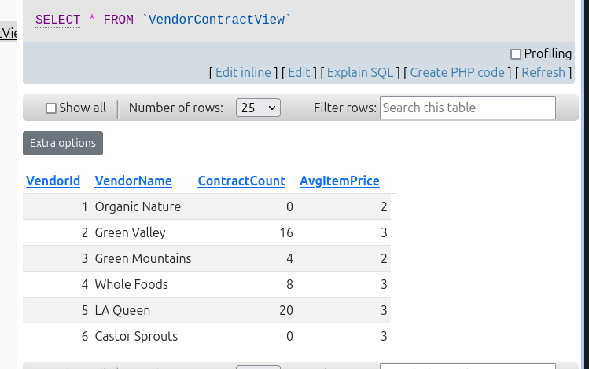

QV1

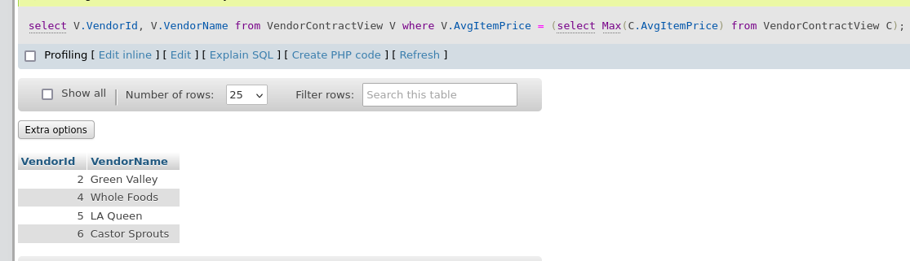

QV2

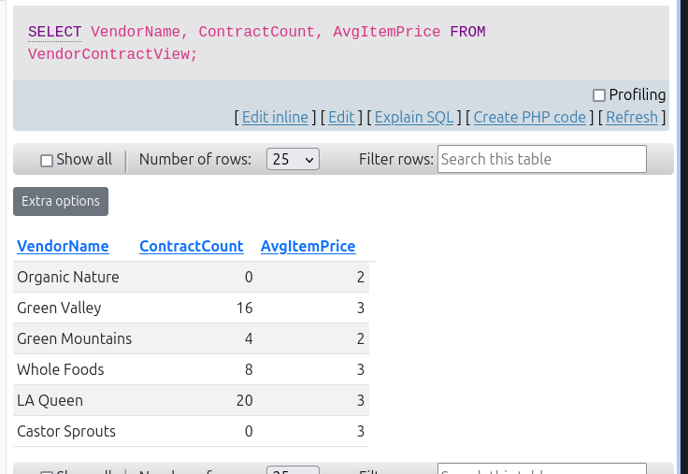

QV3

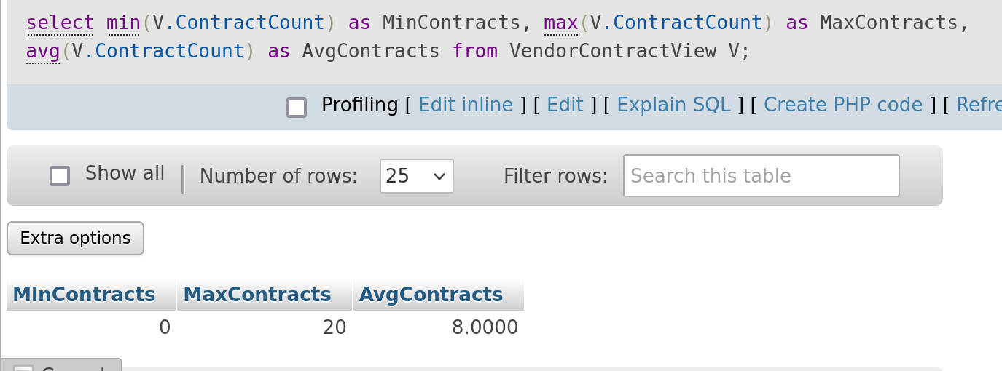

QV4

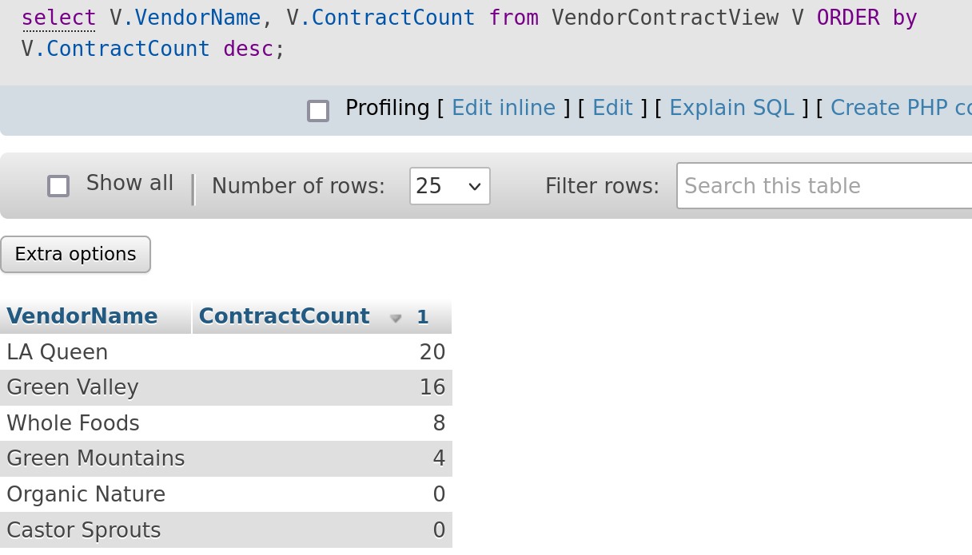

QV5  
